DISASTER DETECTION

Arjarapu Shabarriesh, M B V Sandeep Reddy, A V Rohith Kumar, DR. Sampath A K
Information Science & Technology & Presidency University, Bengaluru
Information Science & Technology & Presidency University, Bengaluru
Information Science & Technology & Presidency University, Bengaluru
Professor in School of Computer Science and Engineering & Presidency University, Bengaluru
***

Abstract - This paper introduces the Disaster Prediction Dashboard, a machine learning tool designed to predict the risks associated with hurricanes, earthquakes, and floods. It allows users to upload their own datasets, effectively managing missing values through imputation and enhancing accuracy with scaling techniques. By utilizing models such as random forest and logistic regression, it forecasts hazardous events based on various environmental factors, including wind speed, temperature, rainfall, and soil moisture. The methodology encompasses data preprocessing, feature selection, model training, and accuracy evaluation. Users can easily interact with a straightforward interface to upload data, enter specific values, and receive forecasts accompanied by clear risk indicators. With a focus on achieving high accuracy in risk classification, the system aims to improve disaster preparedness and aid in decision- making. Its scalability and user-friendly design highlight the successful application of machine learning in tackling environmental challenges.

Key Words: Disaster prediction, machine learning, Random Forest, Logistic Regression, risk assessment

INTRODUCTION

Disasters pose significant risks to life, property, and ecosystems, making accurate prediction and preparedness crucial. The advancement of machine learning (ML) offers a promising solution to predict and mitigate these risks effectively. This paper introduces the Disaster Prediction Dashboard, a user-centric tool designed to forecast environmental hazards such as hurricanes, earthquakes, and floods. By leveraging robust ML models like random forest and logistic regression, the system analyzes critical environmental factors—including wind speed, rainfall, temperature, and soil moisture—to
identify potential risks with high accuracy.The dashboard provides an intuitive interface where users can upload datasets, handle missing values through automated imputation, and obtain detailed risk assessments. This ensures accessibility for diverse users, including policymakers and disaster management teams. The integration of data preprocessing, feature selection, and model evaluation contributes to the tool's reliability.

By enhancing early warning systems and informed decision-making, the Disaster Prediction Dashboard demonstrates the potential of machine learning to address complex environmental challenges. This paper outlines the system's development, technical methodologies, and its implications for improving disaster resilience.

LITERATURE SURVEY

The use of machine learning (ML) techniques in predicting disasters has gained significant attention in recent years, primarily because it improves the accuracy of risk assessments and aids in decision-making for disaster management. Numerous studies have investigated the application of ML models, including Random Forest (RF), Logistic Regression (LR), and Support Vector Machines (SVM), to forecast natural disasters such as hurricanes, earthquakes, and floods. For instance, RF has been extensively utilized to predict the paths and impacts of hurricanes, achieving high accuracy by analyzing vast amounts of meteorological data. LR models have proven effective in forecasting floods by leveraging hydrological data, including rainfall, soil moisture, and temperature. In the realm of earthquake prediction, machine learning algorithms have been employed to examine seismic data, offering early warnings that can help reduce casualties. Data preprocessing is crucial in disaster prediction systems, with techniques like imputation addressing missing data and scaling methods (such as Min-Max

Scaling) ensuring precise predictions. Additionally, the incorporation of user-friendly interfaces in disaster management systems has enabled users to upload data and enter environmental variables, making real-time predictions more accessible to decision-makers. The increasing significance of these systems is clear in their role in disaster preparedness and mitigation. By facilitating quick responses and efficient resource allocation, these systems have become vital tools for minimizing the effects of disasters. This paper seeks to expand on existing methods by proposing a scalable Disaster Prediction Dashboard that integrates advanced machine learning models and an intuitive interface to assess the risk of hurricanes, earthquakes, and floods, ultimately enhancing disaster response strategies.

PROPOSED METHOD

The proposed method for the Disaster Prediction Dashboard leverages machine learning to assess the risks of hurricanes, earthquakes, and floods based on environmental data submitted by users. The process starts with data preprocessing, which addresses missing values through imputation and scales the data to ensure accuracy. Important features like wind speed, temperature, rainfall, and soil moisture are chosen for training the machine learning models. Random Forest (RF) is utilized for its capability to manage complex relationships and large datasets, while Logistic Regression (LR) is selected for its effectiveness in classification tasks. The interface is designed to be user- friendly, allowing users to upload data, enter values for specific features, and receive risk forecasts categorized as low, medium, or high. The system's performance is assessed using standard metrics, guaranteeing reliable and accurate predictions. This approach improves disaster preparedness by offering actionable risk assessments.

ADVANTAGES OF PROPOSED SYSTEM

The proposed system has several key advantages:

Accurate Predictions
It employs machine learning models such as Random Forest and Logistic Regression to assess environmental factors like wind speed, temperature, rainfall, and soil moisture. This leads to precise forecasts for hurricanes, earthquakes, and floods, enabling early warning systems.

User-Centric Interface
Featuring a user-friendly dashboard, the system allows individuals, even those without technical expertise, to easily upload data, enter attributes, and obtain actionable risk forecasts. This simplicity enhances accessibility and encourages broader use.

Data Handling and Accuracy
The system effectively processes raw input data by addressing issues like missing values and scaling for improved model accuracy, ensuring reliable predictions even when the data is incomplete or inconsistent.

High Scalability
This system is designed to be scalable, capable of managing large datasets effortlessly. It can also be modified to predict various natural disasters with minimal adjustments, making it adaptable and future ready.

Reliable Model Performance
By utilizing established machine learning models, the system guarantees strong and trustworthy predictions, which boosts user confidence in the tool for decision- making and disaster readiness.

Enhanced Disaster Preparedness
The capability to predict potential disaster events ahead of time allows users to take preventive measures, ultimately enhancing public safety and reducing damage during natural disasters.

IMPLEMENTATION OF PROPOSED SYSTEM

Architecture

The architecture of the disaster prediction system is crafted to efficiently manage various components, seamlessly integrating machine learning models with a user-friendly interface. It consists of three main layers:

Data Layer
This layer is responsible for gathering and processing input data, which includes historical records of hurricanes and seismic information. Real-time data ingestion is facilitated through APIs linked to meteorological and seismological services.

Processing Layer
This layer runs the prediction models.
  - Random Forest is utilized to forecast hurricanes based on weather parameters such as wind speed and temperature.
  - Regression is employed to predict earthquake occurrences based on seismic signal characteristics.

Application Layer
This layer offers the user interface, enabling users to engage with the system, input data, and access predictions and alerts.

PROJECT WORKFLOW
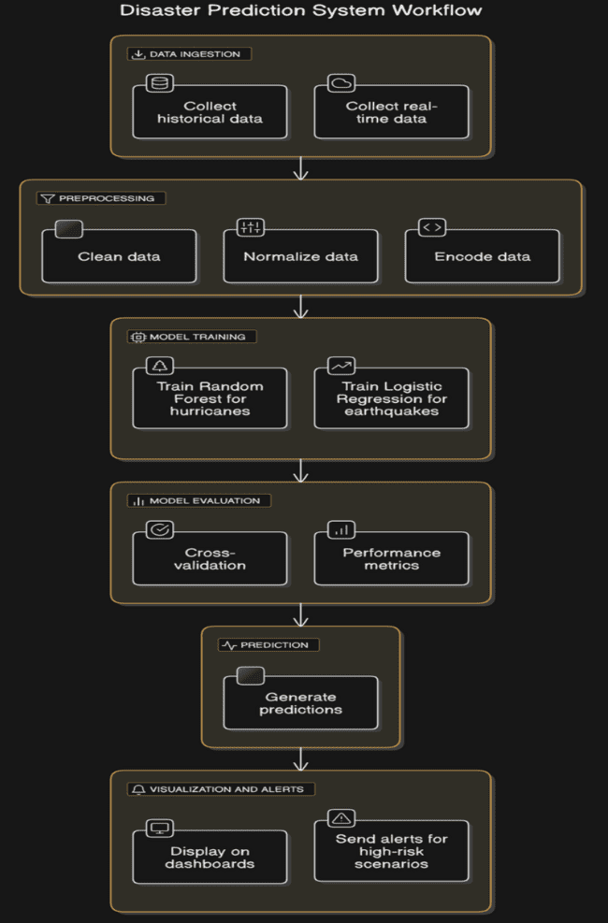

Fig-1 Architecture Diagram

METHODOLOGIES

Data Preprocessing and Feature Engineering

Data preprocessing is a crucial step in developing a disaster detection system. It involves addressing missing data through imputation methods, such as filling in missing values with the mean, median, or the most frequent value, ensuring the dataset is complete for training. Feature scaling is also vital, particularly when using algorithms like Logistic Regression or k-Nearest Neighbors. The Standard Scaler is applied to normalize numerical features, which helps prevent the model from being biased towards features with larger values. Moreover, creating meaningful target variables, such as binary labels for disaster occurrences based on thresholds like wind speed or earthquake magnitude, is essential for making the problem solvable by machine learning models.

Model Training and Hyperparameter Tuning

After preprocessing the data, the next step is to train the model. In this scenario, a Random Forest Classifier is utilized, which is an ensemble learning algorithm capable of capturing complex, non-linear relationships within the data. To enhance the model's performance further, hyperparameter tuning is necessary. Techniques such as Grid Search or Randomized Search can be used to optimize hyperparameters like the number of trees (n_estimators) or the maximum depth of the trees (max_depth). This process helps achieve better model accuracy by selecting the most appropriate parameters for the dataset at hand.

Model Evaluation and Improvement

Once the model is trained, it is important to assess its performance to ensure it generalizes well to new, unseen data. Cross-validation is an effective technique that divides the data into multiple subsets, allowing the model to be tested on various data points and helping to prevent overfitting. Additionally, performance metrics such as F1-score, Precision, Recall, and ROC-AUC are valuable for evaluating the model's ability to make accurate predictions, particularly in scenarios with imbalanced datasets. Analyzing feature importance is also a key part of the evaluation process.

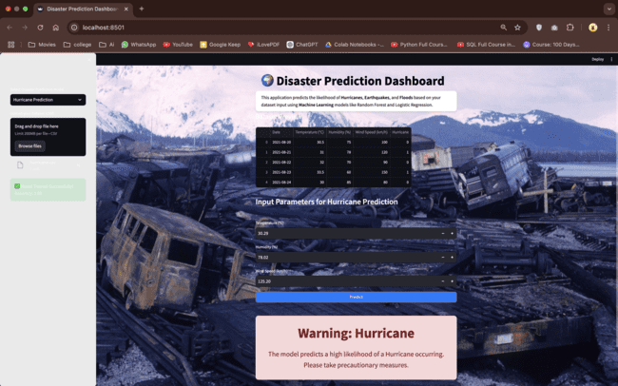
UI Tools and Frameworks

Flask: Used for backend integration and API management.
Streamlit: Handles interactive data visualizations and front-end UI design.

RESULT

This page enables users to choose from three types of disasters (Hurricane, Earthquake, or Flood) and upload a corresponding dataset for the selected disaster. Once the dataset is uploaded, users can enter specific values that will be analyzed alongside the dataset. The system employs machine learning models to produce an accurate prediction, showing the probability of the chosen disaster occurring, which provides essential insights for disaster preparedness and management.

Dashboard: The Disaster Prediction Dashboard is an online tool that employs machine learning models, such as Random Forest and Logistic Regression, to estimate the chances of hurricanes, earthquakes, and floods occurring. Users can choose the type of disaster they are interested in, and the application generates a probability score based on the provided data. The goal of the dashboard is to support disaster preparedness and mitigation strategies.
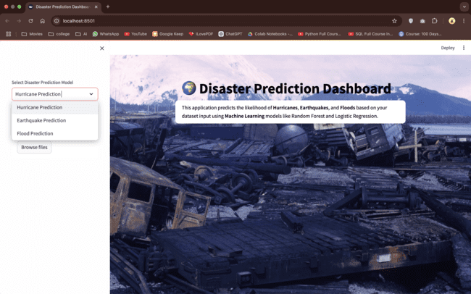

Fig-2 Dashboard of the project

HURRICANE PREDICTION: The "Disaster
Prediction Dashboard" uses machine learning models to forecast hurricane chances based on user-entered parameters. It assesses historical data and provides a probability score for hurricane occurrence, with a warning message for high-risk situations.

Fig-3 Hurricane Prediction

EARTHQUAKE PREDICTION: The "Disaster
Prediction Dashboard" uses machine learning to assess earthquake risks based on user-entered parameters, indicating a low chance of immediate danger.
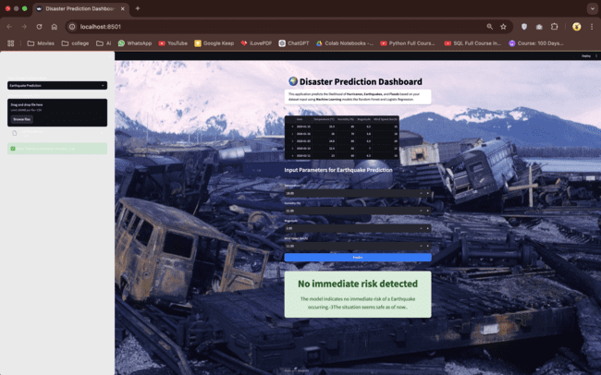
Fig-4 Earthquake Prediction

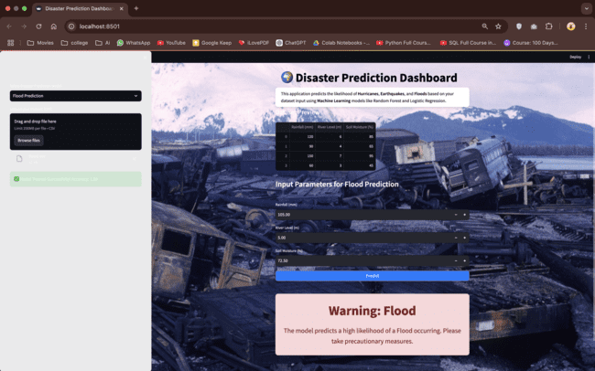
FLOOD PREDICTION: The "Disaster Prediction Dashboard" web app uses machine learning to forecast floods based on user-entered parameters like rainfall, soil moisture, and river levels. Today's prediction: "Warning:

Fig-5 Flood Prediction

CONCLUSION

The Disaster Prediction Dashboard is an innovative tool that uses machine learning to forecast the likelihood of natural disasters such as hurricanes, earthquakes, and floods. By examining historical data alongside real-time information, the dashboard delivers important insights and predictions. This can help individuals, communities, and authorities take proactive steps like evacuating, strengthening infrastructure, and allocating resources. Although the accuracy of these predictions relies on the quality of the data and the limitations of the models, the dashboard serves as a valuable early warning system. Ongoing research and development, as well as educating users and interpreting predictions responsibly, are essential to enhance the effectiveness of this tool in reducing the impact of natural disasters.

REFERENCES
Vinay Chamola , Vikas Hassija , Sakshi Gupta , Adit Goyal , Mohsen Guizani , and Biplab Sikdar ,Disaster and Pandemic Management Using Machine Learning: INTERNET OF THINGS JOURNAL, VOL. 8, NO. 21, NOVEMBER 1, 2021

Jain H, Dhupper R, Shrivastava A, Kumar D and Kumari M , Leveraging machine learning algorithms for improved disaster preparedness and response through accurate eather pattern and natural disaster prediction. Front. Environ. Sci. 11:1194918. doi: 0.3389/fenvs.2023.1194918(2023)

A Review on Disaster Prediction Using Machine Learning Alaa Taiseer Farghaly1* , Ngahzaifa Binti Ab Ghani2 , Abbas Saliimi Lokman ISSN: 2073-607X, 2076-0930 , 16(S1)2024

Labis, Paul Michael. Machine Learning for Disaster Risk Reduction - Review and Research Directions. (2024).

Fakhrul, Md & Sumon, Md Fakhrul Islam & Khan, Azam & Rahman, Arifur & Chikwarti, Dileep Kumar. (2023). Machine Learning for Real-Time Disaster Response and Recovery in the U.S. 14.

Qingsong Xu1 , Yilei Shi2 , Xiao Xiang Zhu ‘Role of Internet of Things in disaster management’, Proceedings of 2017 International Conference on Innovations in Information, Embedded and Communication Systems, ICIIECS 2017, 2018- Janua(September), pp. 1–4. doi: 10.1109/ICIIECS.2017.8275928.(2023)

Leveraging AI for Natural Disaster Management : Takeaways From The Moroccan Earthquake 2023

Linardos, V.; Drakaki, M.; Tzionas, P.; Karnavas, Y.L. Machine Learning in Disaster anagement: Recent Developments in Methods and Applications. Mach. Learn. Knowl. Extr. 2022, 4, 446–473. https://doi.org/10.3390/ make4020020

